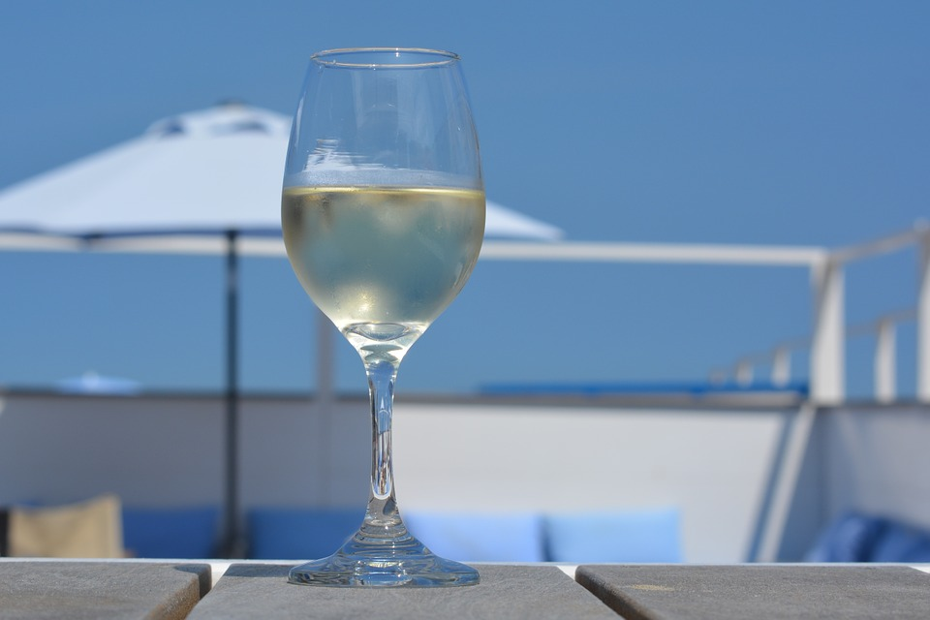  Wednesday  July 25, 2018  “Summer In A Glass”  Join us for a refreshing evening of Rosés & White Wines with WSET Certified Sommelier Ron Bell. A Chicago native, Ron has extensive knowledge of the wine world and will be sharing 5 fabulous tastings. Our full menu will be served, along with a special pairing dish for you to savor. Cheers!   | 5:00-7:30pm  ────  $8 for 5 tastings  ────  25% off Bottle prices  ────  Reservations  Recommended  STINK & EL TUFO  628 ST. Helens Ave  Tacoma  253-426-1347  Stinktacoma@outlook.com

